Support Vector Machines
Overview
- Model complexity and capacity
- Support Vector Classifier
- Soft margins
- Non-linear classification boundaries
- Kernels
Support Vector Machines (SVMs) are a powerful supervised classification model.
They work on the principle of finding a hyperplane that discrimates between two classes in the data.
In the case of binary classification with 2-dimensional data, the hyperplane is just a line that splits the data into two.
Everything on one side of that line is classified as A, everything on the other side is classified as B.
In this unit, we start with the general topic of model complexity or capacity, which gives us a useful background for understanding the motivation of SVMs. We then look at the concept of linear separability and how we can find the best line for splitting the data. This allows us to frame the SVM optimization problem. We also look at how SVMs deal with data that can’t be linearly separated. Sometimes it is enough to use soft margins, but in many other cases we need non-linear classification boundaries, for which kernels are very useful.
Model complexity and capacity
- Key challenges in machine learning: underfitting and overfitting
- Tendency to underfit or overfit can be controlled by changing model’s capacity
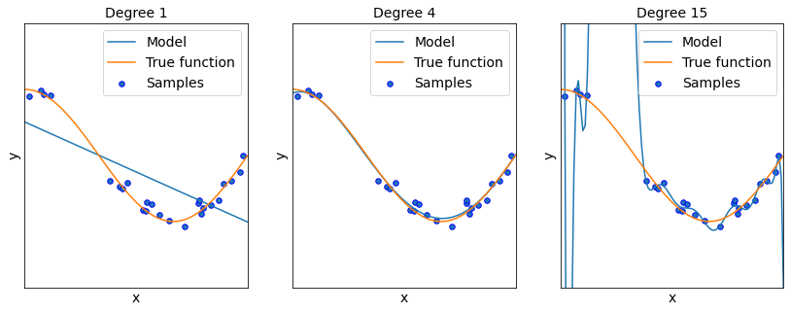
In machine learning, there are two key challenges: underfitting and overfitting.
Underfitting means that the model is not able to fully utilise the information in the data and is biased by its original design.
On the other hand, overfitting means that the model puts too much attention on the training data and cannot generalize well to new unseen data - the model captures too much of the variability in the data. For example, the model could simply memorize some properties of the training data that fail to generalize to new data.
Neither of them are good and we can control the tendency of the model to either underfit or overfit by changing its capacity or complexity. Capacity can be understood as the ability of the model to fit various functions.
As you can see on the plot, a polynomial of degree 1 is too simple and leads to underfitting, while polynomial of degree 15 leads to overfitting. A polynomial of degree 4 looks like the right trade-off between underfitting and overfitting and is able to capture the behaviour well.
Model complexity and capacity
- Vapnik & Chervonenkis: Test error ≤≤ Training error + Model complexity
- Training error often smaller for models with larger capacity - but they can overfit
- If training error is 0, we can minimize model capacity to improve test performance
  - Possible when the data are linearly separable
You may find it very interesting to know that we can find an upper bound on the test or generalization error. More precisely, Vapnik & Chervonenkis showed that the test error is bounded from above by the sum of the training error and a term involving model complexity. We can simplify it using the formula on the slide: test error is less than training error plus model complexity. Model complexity is the same as model capacity and we use these two terms interchangeably.
Training error is often smaller for models with larger capacity - but there is a risk that more complex models can overfit, which is the reason why model complexity is a factor.
In some cases it is possible to reach training error of 0, and if this is the case, we can minimize model capacity to improve test performance. We will talk about this after introducing the concept of linear separability.
How to measure complexity?
VC dimension:
- Capacity of a binary classifier
- What is the largest possible mm so that we can arbitrarily label mm different points?
Example:
- Model ff is a simple threshold classifier for real numbers
  - Return class 1 if the value is more than kk, otherwise return class 0
- If we have two points and the smaller one is classified as 1, the larger one cannot be classified as class 0
- VC dimension is one because only one point can be arbitrarily classified
Before we proceed to linear separability, we discuss model complexity a little more to give you more background in the relevant foundations. You may be wondering - how can we measure the complexity of a model? We often simply use our intuition, but we can also be more precise in certain settings.
Let’s introduce VC dimension, which measures the capacity of a binary classifier. It specifically answers the question - what is the largest possible mm so that we can arbitrarily label mm different points?
It is a lot easier to understand this using an example. Imagine model ff that is a simple threshold classifier for real numbers. It returns class 1 if the value of a point is more than kk, otherwise it returns class 0. If we have two points and the smaller one is classified as 1, the larger one cannot be classified as class 0. As a result, VC dimension is one because only one point can be arbitrarily classified.
Linear separability
- Binary classification
- Classes are linearably separable
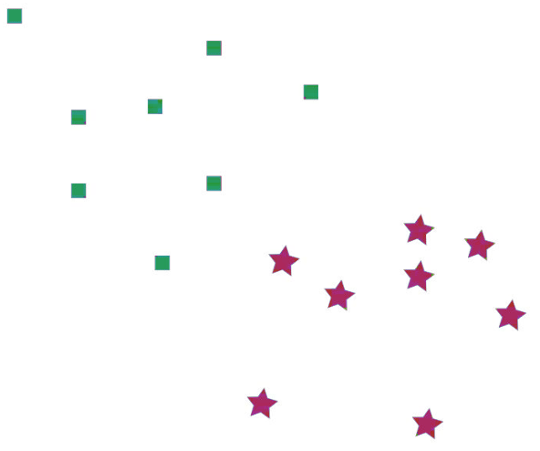
SVMs rely on the concept of linear separability.
In the 2D case, this means given some data points, we can divide them into two classes by drawing a line between them.
Ideally, all of one class will be on one side of the line, and all of the other class on the other side.
When we want to make a prediction for a new point, we just need to see what side of the line it is on.
Finding a line
- Many possible seperating lines
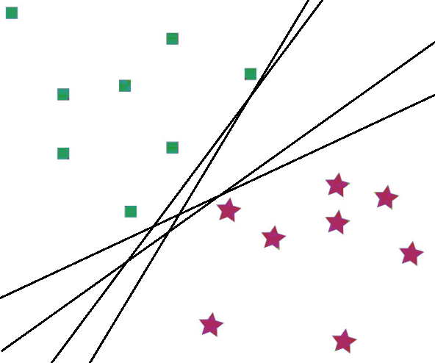
There are many possible lines that would separate the classes.
Finding a line
- Many possible separating lines
- Best one is maximally distant from both classes
- Points on the margin are support vectors
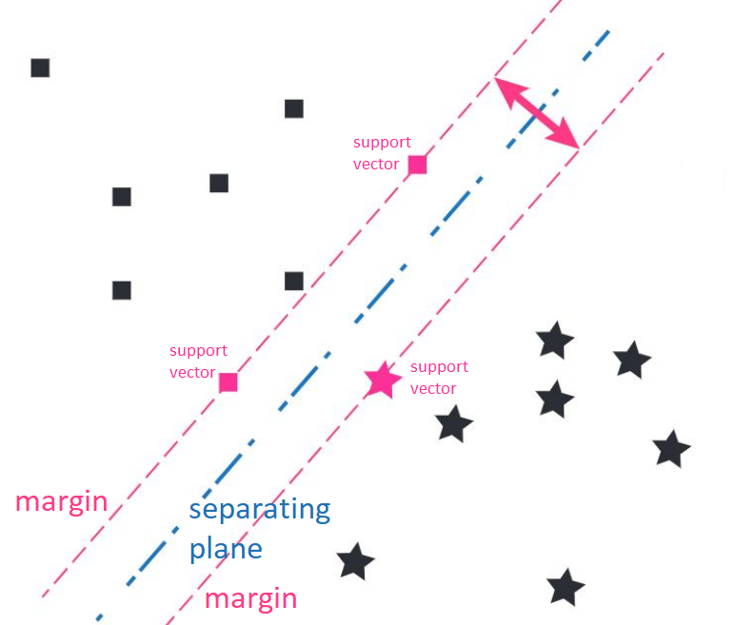
The optimal separating plane can be determined by minimising the distance from just a few key data points. These points are the support vectors.
If you move any of the other points while determining the optimal margin, the margin won’t change.
Evaluating a line
Using linear algebra, we can show the distance between a point xx and the
hyperplane wT⁡x+w0=0wTx+w0​=0 is
1∥w∥∣wT⁡x+w0∣∥w∥1​∣wTx+w0​∣
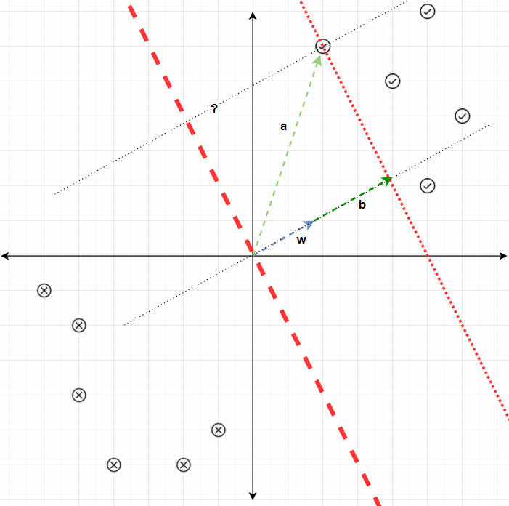
To find the optimal line, the first step involves measuring the distance between the line and a given point. This can be accomplished using linear algebra. The equation of the plane can be represented in a specific form, and by determining the orthonormal vector for the line, one can project it onto a line directly towards the desired point.
The separating line is defined by its margins: the distance between it and the nearest example of each class.
The best line has the largest margin. This is important for classifying new data points - if the margin is closer to one class than the other, then it may be biased towards predicting one class over the other. Otherwise, you could just skip all this work and use any line that separates the classes!
By performing the necessary calculations, we can establish the distance between a point xx and the
hyperplane wT⁡x+w0=0wTx+w0​=0 is
1∥w∥∣wT⁡x+w0∣.∥w∥1​∣wTx+w0​∣.
This formula is particularly valuable as it allows us to determine the margin’s value, providing crucial information for the classification process.
Margin
- For points on the hyperplanes wT⁡x+w0=±1wTx+w0​=±1, their distance to the decision boundary can be calculated with
min⁡i1∥w∥∣wT⁡xi+w0∣mini​∥w∥1​∣wTxi​+w0​∣
- To remove scaling degree of freedom, we constrain to:
min⁡i∣wT⁡xi+w0∣=1mini​∣wTxi​+w0​∣=1
- And the distance can then be easily calculated as
±1∥w∥±∥w∥1​
- We can define the margin mm as the distance from the support vectors to the hyperplane with: m=2∥w∥m=∥w∥2​
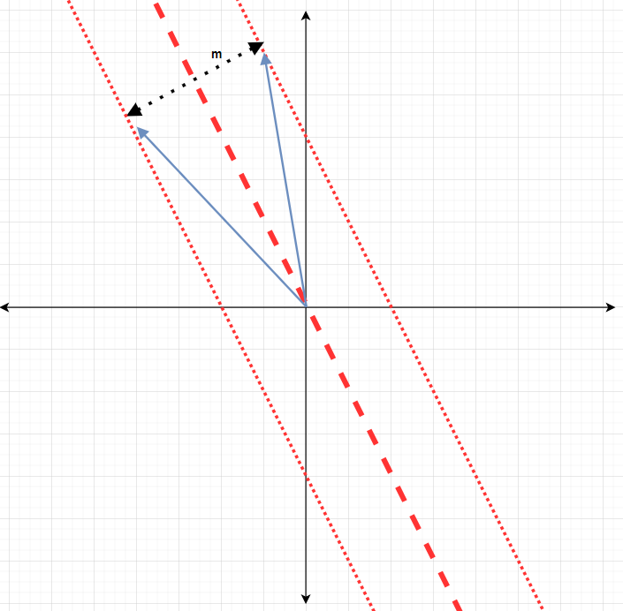
Margin mm is defined as the distance from the closest training point to the separating hyperplane and can be calculated as
min⁡i1∥w∥∣wT⁡xi+w0∣.mini​∥w∥1​∣wTxi​+w0​∣.
To calculate the margin, we simply compute the distance between each point and the separating hyperplane and select the minimum value among them.
An interesting observation is that the equation of the hyperplane remains unchanged when multiplied by any number cc. To eliminate this freedom and establish a standard representation, we introduce a constraint:
min⁡i∣wT⁡xi+w0∣=1.mini​∣wTxi​+w0​∣=1.
By applying this constraint, we can easily compute the margin mm using m=2∥w∥m=∥w∥2​
Maximum margins and model capacity
- Consider hyperplanes wT⁡x+w0=0wTx+w0​=0 normalized so that min⁡i∣wT⁡xi+w0∣=1mini​∣wTxi​+w0​∣=1 for data xixi​
- Analysis from Vapnik & Chervonenkis showed we can minimize ∥w∥2∥w∥2 to have lower capacity
- If the data are linearly separable, training error is 0, and we can simply minimize the capacity of the model quantified by ∥w∥2∥w∥2
- Minimizing ∥w∥222∥w∥2​ is the same as maximizing the margin 2∥w∥2∥w∥22​ of the classifier
- Maximizing the margin implies minimizing the capacity
Now that we have discussed margins and SVMs in general, we can discuss the connection between maximum margins and model capacity.
Let’s consider hyperplanes wT⁡x+w0=0wTx+w0​=0 normalized such that min⁡i∣wT⁡xi+w0∣=1mini​∣wTxi​+w0​∣=1 for data xixi​. Analysis from Vapnik & Chervonenkis showed we can minimize ∥w∥2∥w∥2 to have lower capacity.
If the data are linearly separable, training error is 0 and we can simply minimize the capacity of the model quantified by ∥w∥2∥w∥2.
As we have just observed, the margin of the classifier is calculated as 2∥w∥∥w∥2​, so minimizing ∥w∥222∥w∥2​ is equivalent to maximizing the margin of the classifier.
SVM optimization problem
- We want to maximize the margin subject to linear separability of the data and the normalization constraint
- Formally:
min⁡w∥w∥2minw​∥w∥2
such that
wT⁡xi+w0≥1for all i with yi=1wTxi​+w0​≥1for all i with yi​=1
wT⁡xi+w0≤−1for all i with yi=−1wTxi​+w0​≤−1for all i with yi​=−1
- It can be further rewritten to:
yi(wT⁡xi+w0)≥1for all iyi​(wTxi​+w0​)≥1for all i
- Quadratic optimization problem
The general idea is that we want to maximize the margin subject to linear separability of the data and the normalization constraint.
Minimizing ∥w∥222∥w∥2​ is the same as maximizing the margin 2∥w∥2∥w∥22​ of the classifier
It is possible to write the optimization problem in a more concise way:
yi(wT⁡xi+w0)≥1yi​(wTxi​+w0​)≥1 for all ii. We have combined the two constraints into one using the fact that the classes are either 1 or -1.
As a result, we obtain a quadratic optimization problem that can be solved using one of the various available tools and techniques specifically designed for such problems.
Making predictions
- When given a new data point xixi​, it is enough to look at the sign:
y^i=sign(wT⁡xi+w0)y^​i​=sign(wTxi​+w0​)
- Predict class 1 if wT⁡xi+w0wTxi​+w0​ is positive, otherwise predict class -1
To make a prediction for a given data point xixi​, we examine the sign of wT⁡xi+w0wTxi​+w0​. If wT⁡xi+w0wTxi​+w0​ is positive, we predict it belongs to class 1; otherwise, we predict it belongs to class -1.
Relaxing the margin
- Data often not linearly separable
- We want to:
  - Encourage a large margin
  - But penalise misclassified points, with larger penalty for larger errors
In practical scenarios, data often exhibits some degree of “fuzziness” and overlap, making it challenging to achieve perfect linear separability. However, this doesn’t necessarily require us to seek an entirely different model. Instead, we can address this issue by slightly relaxing the margins.
Relaxing the margin
- Solution: a soft margin
  - Minimise ∥w∥2∥w∥2 and the errors
- Introduce a “slack” variable ξi≥0ξi​≥0 for each training example
- The new optimization problem is min⁡w∥w∥2+C∑i=1nξiminw​∥w∥2+C∑i=1n​ξi​
such that wT⁡xi+w0≥1−ξifor all i with yi=1wTxi​+w0​≥1−ξi​for all i with yi​=1
wT⁡xi+w0≤−1+ξifor all i with yi=−1wTxi​+w0​≤−1+ξi​for all i with yi​=−1
To incorporate soft margins into the SVM, we introduce a concept of “slack” variables, denoted as ξi≥0ξi​≥0, for each training example. By doing so, we modify the optimization problem to minimize both ∥w∥2∥w∥2 and the errors that contribute to the soft margins.
The introduction of slack variables allows for a more flexible classification of the training data by providing additional leeway. The degree of flexibility is controlled by a hyperparameter CC, which determines the margin’s behavior and how much freedom is given to the slack variables.
Relaxing the margin
Regularization hyperparameter CC controls the margin and determines how much a classification error is penalised.
- Small CC : softer margin, classification mistakes are given less importance and focus is more on maximizing the margin.
- Large CC : harder margin, the focus is more on avoiding misclassification at the expense of keeping the margin small.
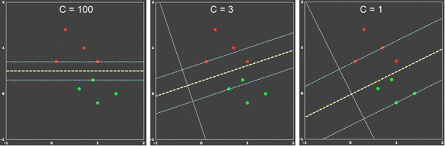
When the value of CC is small, it corresponds to a softer margin in the SVM model. This means that the margin is larger, allowing for some degree of misclassification. On the other hand, a larger value of CC leads to a harder margin, where the margin becomes smaller, and the model prefers a clearer separation between the classes.
To illustrate this, consider the case of a large CC value. In this scenario, the focus is primarily on maximizing the margin, even if it means that the support vectors (points located within the margin) do not align perfectly with the separation between classes.
In contrast, a moderate level of CC tends to strike a balance. It considers both the margin and a larger number of support vectors, including all the points located within the soft margin. This middle ground allows for a compromise between maximizing the margin and considering a broader range of support vectors.
Non-linear data
Not all data are neatly separable, even with relaxed margins
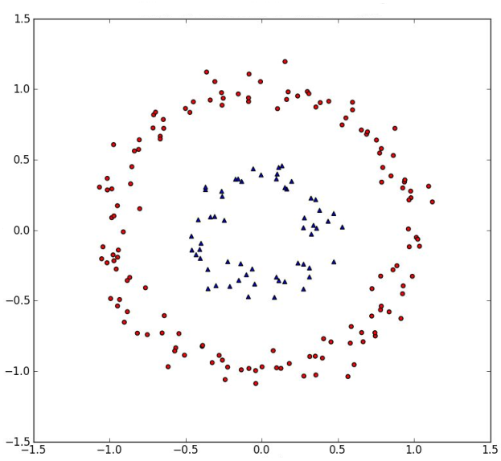
In certain cases, simply relaxing the margins is insufficient because there are situations where it becomes impossible to separate the data into two distinct classes using a line, plane, or hyperplane.
Non-linear data
Solution:
- Embed the data in a higher dimensional space
- Apply your SVM
- Invert the embedding back to original space
Can do this all in one go using a kernel
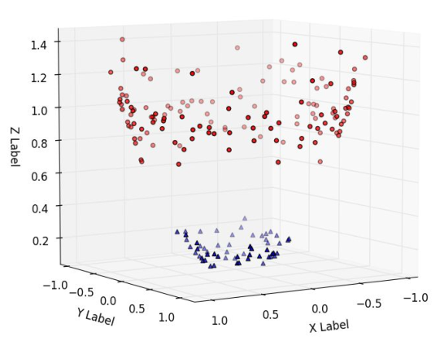
One solution is to take a different perspective on the data and embed it in a higher dimension - what seems like one circle inside another when viewed from above in two dimensions could be seen as a smaller ring underneath a larger one. For example, if you plot all the 2D points (xx,yy) as 3D points (xx, yy, x2+y2x2+y2) - this maps the 2D points onto a paraboloid.
The points in this new space are then very easily separated using a plane.
For SVMs, the three steps of embed > SVM > invert can be done in a single step using a kernel.
Feature mapping and kernels
- Mapping function ΦΦ
  - Converts from original space to new one (e.g. 2D to 3D)
  - E.g.: (x1,x2)→(x12,2x1x2,x22)(x1​,x2​)→(x12​,2​x1​x2​,x22​)
- A kernel function gives the inner product between two points in a transformed space
  - k(x,x′)=ϕ(x)T⁡ϕ()k(x,x′)=ϕ(x)Tϕ(x′)
- Kernel trick: calculate the inner product and then do transformations instead of calculating new features ϕϕ and then taking the inner product
  - E.g. directly do k(x,x′)=(x⋅x′)2k(x,x′)=(x⋅x′)2
- Various kernels available:
  - Polynomial, Radial basis function (RBF), …
In order to transform our features into a new space, we can define a mapping function ϕϕ that converts from the original space to the new one (e.g. 2D to 3D).
A kernel function calculates the inner product between two points in a transformed space. However, calculating the new features is often expensive and in some cases even impossible.
This is where the so-called kernel trick becomes very useful: calculate the inner product and then do transformations, instead of calculating new features ϕϕ and then taking the inner product. For example, we can take the inner product between x,x′x,x′ and then take the square rather than explicitly calculating the quadratic features in the new space.
There are various kernels available, we will discuss more details about polynomial and RBF kernels which are some of the most common ones.
If your data can be easily separated linearly, it is recommended to utilize a standard Support Vector Machine (SVM) during practical implementation. However, if linear separation is not feasible, you can modify the parameter C to allow for wider margins. In cases where the data proves to be extremely challenging to separate, employing kernel functions is advisable.
Polynomial kernel
- Polynomial kernel of order dd: k(x,x′)=(x⋅x′)dk(x,x′)=(x⋅x′)d
- Explicit mapping (from 2D to 3D):
ϕ((x1,x2))⋅ϕ((x1′,x2′))=(x12,2x1x2,x22)⋅(x1′2,2x1′x2′,x2′2)=x12x1′2+2x1x1′x2x2′+x22x2′2ϕ((x1​,x2​))⋅ϕ((x1′​,x2′​))=(x12​,2​x1​x2​,x22​)⋅(x1′2​,2​x1′​x2′​,x2′2​)=x12​x1′2​+2x1​x1′​x2​x2′​+x22​x2′2​​
- Kernel trick:
k(x,x′)=(x⋅x′)2=((x1,x2)⋅(x1′,x2′))2=(x1x1′+x2x2′)2=x12x1′2+x22x2′2+2x1x1′x2x2′k(x,x′)=(x⋅x′)2=((x1​,x2​)⋅(x1′​,x2′​))2=(x1​x1′​+x2​x2′​)2=x12​x1′2​+x22​x2′2​+2x1​x1′​x2​x2′​​
- Kernel trick is a lot more efficient for many dimensions!
  - No need to calculate the features
Polynomial kernel of order dd can be calculated easily by taking the dot product between x,x′x,x′ and then taking a power of order dd. This is a lot more efficient than explicitly calculating the features in the new space, as you can see on the simple 2D to 3D example.
RBF kernel
- Kernel: k(x,x′)=exp⁡(−γ∥x−x′∥2)k(x,x′)=exp(−γ∥x−x′∥2)
- One of the most popular and powerful kernels
- Can be visualized as a “bump” (Gaussian) around each data point, with the spread controlled by γγ
- Feature map would have an infinite number of dimensions, so cannot calculate it
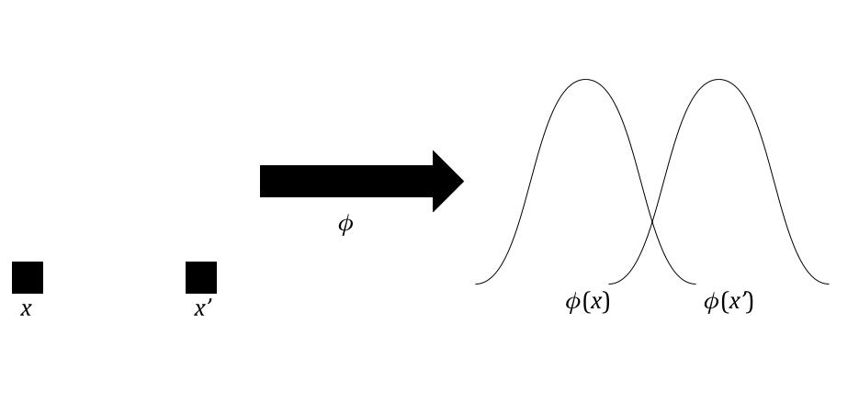
The Radial Basis Function (RBF) kernel is frequently preferred due to its enhanced expressive capabilities compared to a polynomial kernel. It derives its strength from being based on the Gaussian function. The RBF kernel can be conceptualized as a “bump” or Gaussian shape around each data point, where the width of the bump is controlled by the parameter γγ. One intriguing aspect of the RBF kernel is that its associated feature map has an infinite number of dimensions, making it infeasible to compute directly.
SVMs in practice
- Implemented in sklearn.svm with various kernels
- Generally very strong performance for classification
- Predictions can come with probabilities/scores
- Depending on the kernel used, can also get feature importance
A lot of the technical details here don’t really come into play when actually using SVMs - they have very few hyperparameters (just the kernel and the value for C), and everything is well implemented in sklearn.
Additionally, there are probabilistic extensions to the SVMs which allow you to see how confident the model is with its classification. This can let you examine edge cases which the model was less sure about. And using a linear kernel lets you see which features were most informative, just as you can with other linear models such as linear regression.
Strengths of SVMs
Strengths:
- Good for high dimensional spaces
- One unique solution
- Versatile thanks to the use of kernels
- Very strong performance
To conclude our lesson, let’s examine the strengths and weaknesses of Support Vector Machines (SVMs). SVMs exhibit excellent performance in high-dimensional spaces, making them applicable to complex problem domains. Additionally, their quadratic optimization problem guarantees a unique solution, ensuring stability in their results. The versatility of SVMs is augmented by their ability to incorporate kernels, enabling effective handling of nonlinear data. Lastly, SVMs are renowned for their robust performance, delivering strong predictive capabilities.
Weaknesses of SVMs
Weaknesses:
- Quadratic optimization can be expensive
- Binary classification only
  - Typically solved by using multiple one-vs-all or one-vs-one SVMs
- Need to choose parameter CC and the type of kernel
- Probability estimates are not provided directly and often need expensive cross-validation
1. Quadratic optimization: The quadratic optimization process involved in SVMs can be computationally expensive, especially when dealing with large datasets.
2. Limited to binary classification by default: SVMs are originally designed for binary classification. While there are extensions available to handle multi-class problems, such as one-vs-all or one-vs-one approaches, these extensions can introduce additional complexity and computational overhead.
3. Hyperparameter tuning: Selecting the appropriate values for the regularization parameter C and the kernel type is crucial for optimal SVM performance. This often requires conducting additional experiments or employing techniques like grid search, which can be time-consuming and resource-intensive.
4. Probability estimates and cross-validation: While SVMs can provide probability estimates, they are not readily available and require additional steps, such as costly cross-validation techniques, to obtain reliable probability outputs.
Awareness of these limitations helps in understanding the practical considerations and trade-offs associated with utilizing SVMs in different scenarios.

